# [Researching News (JNL6006)]

Patch Portfolio

# [Registration ID: 170134495]

# [Articles and Commentaries: 2254

# Transcript:1554 ]

|  |  |
| --- | --- |
|  | I affirm that all sentences or passages quoted in this paper from other people’s work (with or without trivial changes) have been placed within quotation marks, and specifically acknowledged by reference to author, work and page. I understand that plagiarism - the unacknowledged use of such passages – will be considered grounds for failure in this paper, and, if serious, in the degree examination as a whole. |
|  | I affirm that is my final submission and has been submitted successfully complete with diagrams and formatting. |

|  |  |
| --- | --- |
|  | I am entitled to accessible assessment stickers – known as ‘yellow stickers’  (see guidance for students at http://www.sheffield.ac.uk/ssid/disability/useful-info/yellow-stickers) |

**Teach Wild Sheffield urge local schools to increase outdoor learning**

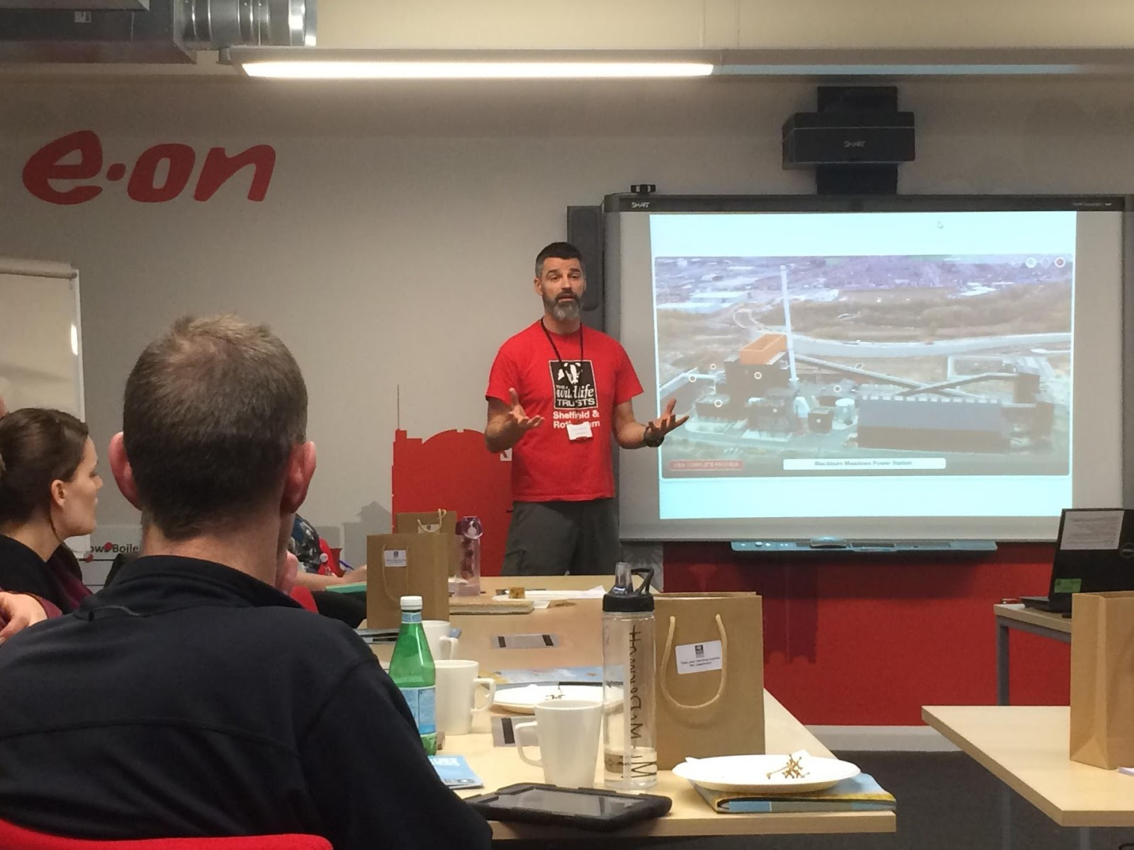

Increasing outdoor learning opportunities in local schools could improve pupil participation and focus, say Sheffield and Rotherham Wildlife Trust.

The organisation hosted a network meeting for local teachers last night at the E.ON Blackburn Meadows Biomass Plant. This is part of their Teach Wild Sheffield initiative.

“One thing we are keen on doing is introducing educational outdoor activities into everyday school life”, said Christopher Smith, Senior Outdoor Learning Officer.

“Providing constant access to nature is so important for these kids. Studies show learning outdoors has a positive impact on academic learning.”

Last year a National Trust survey found children spend half as much time playing outside as their parents did. The study showed this indoor lifestyle is having a negative effect on their mental health and ability to concentrate.

With growing concerns over young people’s reliance on electronic devices for entertainment, the charity group are working to break these modern trends.

**VIDEO:** [**https://www.youtube.com/watch?v=2W1vftew0uc**](https://www.youtube.com/watch?v=2W1vftew0uc)

Fire building and den making are among the activities available for Sheffield schools. The Trust plan to train local teachers to feel confident in leading lessons outside of the classroom.

Charlotte Varley, a teacher from Prince Edward Primary School, said “If we can give children these first-hand experiences they will learn more effectively. By teaching them outdoors, we are taking away barriers in their learning.”

The Trust are running several schemes as part of their Teach Wild campaign including the 30 Days Wild challenge. The challenge will encourage local school children to complete a ‘Random Act of Wildness’ every day of June 2018.

“Our school is next to some amazing woodland and it is great that we get to use it”, said Stephen Vincent, a Learning Support Assistant from Grenoside Community Primary School.

“By taking part in these outdoor lessons you feel like you are discovering with the children. You are more connected. You are sharing these wonderful moments with the students.”

To find out more about the Teach Wild Network visit:

<http://www.wildsheffield.com/teachwildnetwork>

@TeachWildSheff

**Mobile story**

**Word count: 337**

**Commentary**

I sourced this story through researching organisations who work within my patch on Twitter. I searched various hashtags (e.g #LowerDonValley #Meadowhall etc.) and selected the ‘people’ tab on the results page. This allowed access to an array of local profiles including The Sheffield and Rotherham’s Wildlife Trust account (@WildSheffield.) Whilst exploring their main page I found a partner profile @TeachWildSheffield, an account for their Teach Wild Sheffield campaign. After further research I came across the tweet below. I thought it provided the opportunity to attend a more unconventional local meeting.

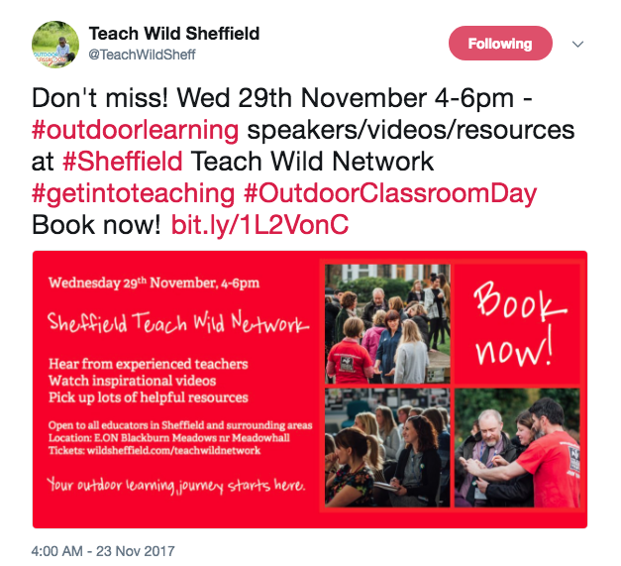

While I enjoyed filming and editing the mobile video, which I believe it to be my strongest piece of multimedia, the photo for this story is a weakness. It was not until I had left the meeting that I realised I did not have a strong image. My first plan was to use the photo below but I decided against this. Though poorly executed, I chose to include the featured photo as it depicts people. Given the chance to improve this I would think more creatively and perhaps even choreograph a photo. From this I have learnt to consciously pay attention to gathering equal quality multimedia across a story.

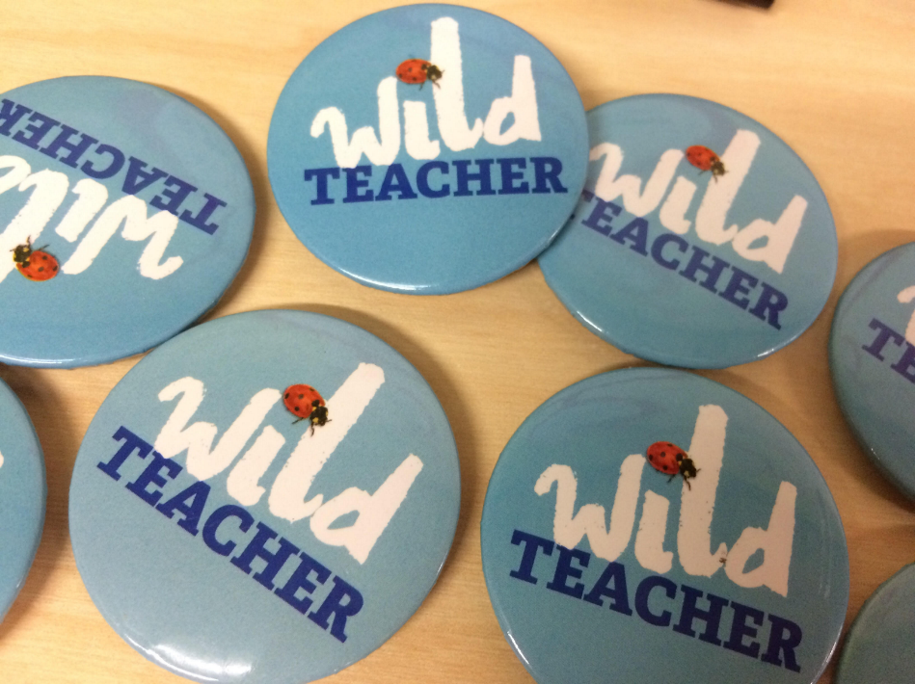

Another concern I have is the strength of the news angle. Though the topic is interesting and there is definite appeal to the local community, I am unsure if I communicated the message with enough impact and evidence. While the National Trust survey was included perhaps more data/context was needed.

However, covering this meeting not only allowed an opportunity to take down shorthand in a more professional environment, but it also put into perspective the way a patch journalist must successfully multitask when collecting content.

**Contact details**

Christopher Smith, Wildlife Trust Senior Outdoor Learning Officer - [c.smith@wildsheffield.com](mailto:c.smith@wildsheffield.com)

Jane Campbell,  Wildlife Trust Digital Communications Officer - [j.campbell@wildsheffield.com](mailto:j.campbell@wildsheffield.com)

                                                                                                                 -  07786574676

Charlotte Varley, Prince Edward Primary School –  Spoken to at meeting

Stephen Vincent, Grenoside Community Primary School – Spoken to at meeting

Matthew Ross, Wildlife Trust Outdoor Learning Assistant - Spoken to at meeting

*Date and time of meeting: Wednesday 29th November 4-6pm*

**Sheffield locals relaunch save Zion Graveyard campaign**

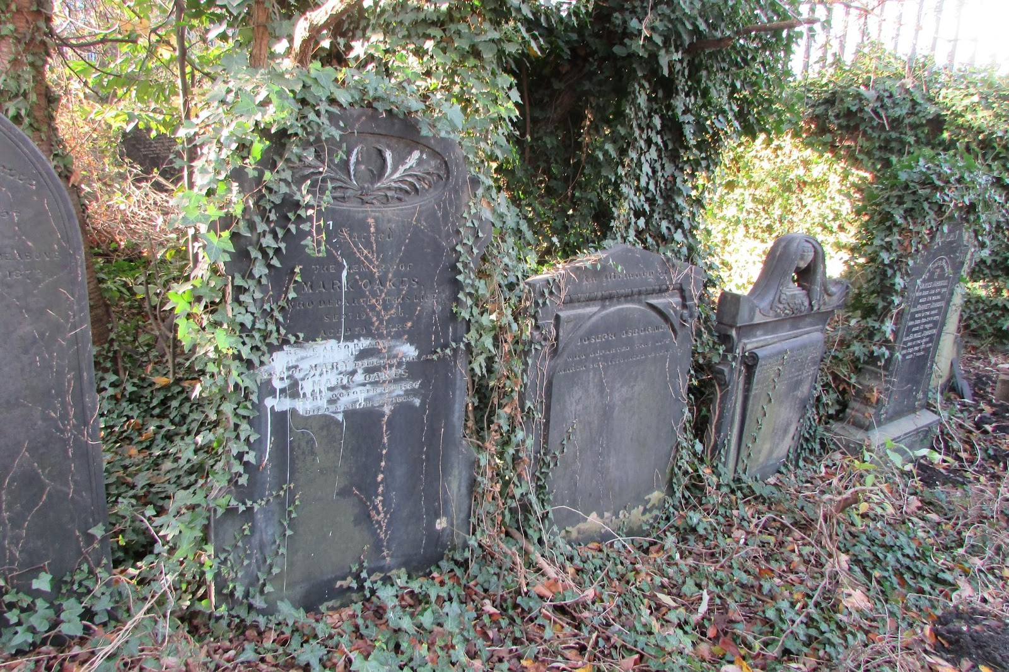

Friends of Zion Graveyard, a community group from Attercliffe, have relaunched their campaign to save a local hidden graveyard. The group are appealing for donations to purchase the site and save it from commercial development.

“When we realised that not only was the graveyard up for sale, but there were serious offers being discussed for the land to be cleared and levelled, we knew we had to do something”, said Penny Rea (62) Chair of Friends of Zion Graveyard.

“It’s really significant in the heritage of the area that we preserve some markers of its important industrial past. We think it’s crucial for the self-esteem of Sheffield.”

The graveyard was first discovered by the group in their search for the graves of Victorian philanthropists Joseph and Elizabeth Read. When searching for the Read family’s final resting place, the local activists saw the site advertised for sale by the United Reform Church early this year.

After gaining access to the locked burial ground, the grave of Mary Anne Rawson was also found. The eldest Read daughter was a leading anti-slavery campaigner in the 19th century. The group are currently seeking listed status with Historic England for this grave.

**VIDEO:** [**https://www.youtube.com/watch?v=Z88BlJ0k0Us**](https://www.youtube.com/watch?v=Z88BlJ0k0Us)

As well as relaunching a Just Giving page, the volunteers have submitted an application to the Heritage Lottery Fund.

“We are also in the process of applying for charitable status”, said Penny Rae. “We are excited to prove that we have charitable aims and are a benefit to the community”

The plot is planned to be used as an educational resource for local schools. Friends of Zion Graveyard have also proposed creating a wildlife garden, an idea supported by Sheffield and Rotherham Wildlife Trust.

Wildlife Trust CEO Liz Ballard said, “The Friends of Zion Graveyard is a really exciting and fabulous project. We hope they will get funding and they can save the graveyard for future generations to enjoy.”

The group have until January 2018 to raise sufficient funds or the graveyard will be back on the market.

To find out more about the campaign visit:

<http://www.ziongraveyard.btck.co.uk/>

To donate visit:

<https://www.justgiving.com/crowdfunding/ziongraveyardattercliffe>

**DSLR story**

**Word count: 357**

**Commentary**

Similarly to my first article I sourced this story on Twitter. After searching through local events, I noticed several people had tweeted a link to a Facebook event for an open day at the site that had already passed. Intrigued by the topic I looked further into the campaign and found the recently relaunched crowdfunding page. I then joined the Friends of Zion Graveyard Facebook group and also contacted the group directly. Penny Rea agreed to meet with me and allowed me into the graveyard to interview her.

**Facebook event:**

[**https://www.facebook.com/events/161587137910041/**](https://www.facebook.com/events/161587137910041/)

**Facebook group:**

[**https://www.facebook.com/groups/435104566849685/**](https://www.facebook.com/groups/435104566849685/)

**Just Giving page:**

[**https://www.justgiving.com/crowdfunding/ziongraveyardattercliffe?utm_source=Facebook&utm_medium=Yimbyprojectpage&utm_campaign=projectpage-share-owner&utm_term=9YR6bAyBB**](https://www.justgiving.com/crowdfunding/ziongraveyardattercliffe?utm_source=Facebook&utm_medium=Yimbyprojectpage&utm_campaign=projectpage-share-owner&utm_term=9YR6bAyBB)

For this piece I also attempted to contact local councillor, Mary Lea, for comment. Her title as Cabinet Member for Culture, Parks and Leisure made her the perfect fit for the piece. However, there was no response to my email or phone call. Penny had also mentioned Mary’s enthusiasm as an environmentalist but also the difficulties of contacting her.

Overall I am disappointed with my DSLR video. I filmed on a bright day and as the sun shone through the iron fencing the light would constantly change. Because of this the camera was autofocusing throughout the interview. A large amount of the content I filmed was unusable and I found myself having to stretch the footage. I would have preferred to have featured more cut away clips rather than repeatedly showing the interviewee. The lack of focus has also impacted the video’s quality as it is blurred. This is apparent when close ups of the graves can be seen in much higher definition. It was also challenging to set up the tripod on the uneven ground of the site.

What I have learnt from this is to take a moment of reflection when working with more difficult surroundings, to ensure the collected content is usable in terms of both quality and quantity.

**Contact details**

Penny Rae, Chair of Friends of Zion Graveyard - [ziongraveyard@gmail.com](mailto:ziongraveyard@gmail.com)

* 07980143776

*Date and time of interview - 2nd December 10am - 11:30am*

Liz Ballard – CEO Sheffield and Rotherham Wildlife Trust – contacted through

* [r.stevenson@wildsheffield.com](mailto:r.stevenson@wildsheffield.com)
* <http://www.wildsheffield.com/who-we-are/contact-us>

**Tinsley Towers replacement: made with Sheffield in mind**

‘Onwards & Upwards’, the artwork announced to replace the Tinsley Towers, will celebrate Sheffield trade with plans to boost tourism and generate income according to artist Alex Chinneck (33).

The Chelsea College of Art graduate announced the plans for the project earlier this year. A mile-long immersive art trial, made of four 30-metre-tall structures, will mark where the towers used to stand.

Each sculpture will depict a large red brick chimney, a recognised symbol of Sheffield’s industrial past.

“The area in which the artwork will stand it particularly resonates with, largely historically. It’s a region where there was a hive of industrial activity and the architecture of that period was reflected in the large red brick chimneys,” said Chinneck.

“There’s this notion of architectural reintroduction. Where all of these chimneys are gone, they are now being reintroduced, it felt appropriate.”

The piece is a collaboration with local companies and creators. Sheffield based businesses are working on all aspects of the project from its documentation to the installation.

“From the outset of the project we celebrated this notion of ‘made in Sheffield’ and we made a commitment that the entire project would be born from working with companies and creators across the region.”

“We are working with people now that we are going to continue to work with on all of our projects. It doesn’t just make sense from the logistical perspective using people from close by, I think there’s something very important about it. It allows the city the best possible chance to accumulate a sense of ownership while the work is in development.”

“There is a huge amount of capacity in industry in Sheffield and the work celebrates that. It’s optimistic, it’s positive and it’s playful. These aren’t relics of the past; they reference the past but they are only possible through contemporary processes and collaboration. It fits, it makes sense, it felt right.”

A multi-million pound bid has been submitted to the Northern Cultural Regeneration Fund to expand the project. The extra funding would be used to install public toilets, a cafe and improve access routes to the artwork.

Chinneck’s previous works include ‘Six pins and half a dozen needles’, a highly publicised installation permanently displayed at the site of Assembly London. He also created the pop up piece, ‘Pick yourself up and pull yourself together” for Tinsley in September 2017.

“In one weekend we had 2,500 visitors and they were largely people who had never been to the area before. Just in that short space of time people were coming and suggesting this could completely change the area.”

The project is promised to be delivered with a focus on community to create accessible artwork in complex structures.

“The one thing that an artwork of this scale and eccentricity does is generate footfall. Some people see that as a negative thing because they want to be left alone. But with footfall comes people and with people come opportunities.”

The project is set to be complete in Summer 2019.

**Background feature**

**Word count: 508**

**Commentary**

I sourced this story through word of mouth. On the first visit to my patch I went into a local newsagents and asked the cashier if anything came to mind in terms of current news in the area. Although I found the topic interesting my initial concern was the large amount of coverage the story had already received.  I decided to contact the artist behind the project to see if I could find a fresh angle. Alex Chinneck then agreed to a phone interview.

Originally I pursued this story as a new piece but after the phone call with Alex I thought the subject matter was more suited to the structure of a background feature. This is because Alex provided further details of the project’s links to the local area as well as the appeal for extra funding. However, Alex was slightly vague when discussing this (see transcript) I then found further details about the bid and added this to the article to embellish the piece further.

Multimedia may also have been difficult to create for this story. I felt limited to a vox pop video and wanted the article to communicate a deeper insight to the project.

Conducting this interview was a learning experience as Alex had a limited availability and time to speak. I attempted to prepare questions that would produce answers that related directly to the patch in terms of the benefits the artwork would bring to the local area. Upon reflection I asked questions that may have created content too colourful for a news based background feature e.g “Why is the piece titled Onwards & Upwards?”

This story also highlighted the difficulty of balancing the quality and quantity of quotes in the copy. The embedding of quotes into news based articles is something I struggled with throughout the creation of this portfolio. I found reading my stories out loud a key way to attempt to combat this.

**Contact details**

Alex Chinneck - [studio@alexchinneck.com](mailto:studio@alexchinneck.com)

- 07709495655

- 01233421883

*Date and time of interview: Monday 20th November 5pm-5:15pm*

**Alex Chinneck**

**Age: 33**

**Artist/sculptor**

**Onward & Upwards installation interview/transcript**

**Your website states that your work produces “contextually responsive interventions that animate where they stand” how does this relate to your ‘Onwards & Upwards’ project? How is the piece set to respond to its location in Sheffield?**

The area in which the artwork will stand it particularly resonates with, largely historically. It’s a region where there was a hive of industrial activity and the architecture of that period was reflected in the large red brick chimneys. Along the Tinsley Locks and also across Blackburn Meadows where the art work will stand, were [many] of these architectural structures. There’s something nice, there’s this notion of architectural reintroduction. Where all of these chimneys are gone, they are now being reintroduced, it felt appropriate.

[The artwork] looks at the industrial heritage of the area but simultaneously utilises the manufacturing capacity that’s presently within the region. The artworks themselves despite their simple nature do present extremely complex challenges in terms of design, fabrication and installation. The entire artwork is being made in the region and it utilises these strengths and capabilities of Sheffield. In many ways it is contextually responsive historically but also in terms of utilising the skillset that was available close by.

[The sculptures] are contextually responsive materially as well, red brick chimneys once stood there. The material choice had to be one that worked well in this particular situation. Red brick is synonymous with Sheffield and that particular area but also it’s a material that works really well along a canal. I think in areas where there is high vegetation the colour palette will work really well. It’s a material that matures well in an aquatic context. So, the piece is contextually responsive materially, historically and logistically.

**Can you tell more about the local involvement aspect of the project?**

Because of the size of our project, collaboration is a necessity. That extends across all areas of the artwork, from the development of the idea following the initial conception, to the design of the idea, to the making of the idea. As well as focusing on the location of the piece and the documentation of it. [There are all] of these different areas, the signage that surrounds [the piece], the branding, the website. It’s not only about construction but it’s also creative collaboration.

From the outset of the project we celebrated this notion of ‘made in Sheffield’ and we made a commitment that the entire project would be born from working with companies and creators across the region. I was quite anxious to make that particular commitment; given we are going in to unknown territory but it’s really bled through. We are working with people now that we are going to continue to work with on all of our projects. It doesn’t just make sense from the logistical perspective using people from close by, I think there’s something very important about it. It allows the city the best possible chance to accumulate a sense of ownership while the work is in development. It is born from the region. It’s working out really well. I suppose we’ve pissed off a lot of the people we normally work with because we aren’t working with them, but at the same time we are making new relationships within the region and that’s great. I would like to do that more often, increasingly we are making work outside of London. It’s really nice to meet new collaborators and forge partnerships which are again in many ways contextually responsive.

**Why is the piece title ‘Onwards & Upwards’ ?**

My titles are normally incredibly wordy and pretentious (or poetic I don’t know one of the two or maybe somewhere in between.) Given the scale of the artwork and the accessible nature of its personality - in the way that anyone can understand it and enjoy it - and the fact that we are really trying to create this landmark as a public project, it needed a simple title. A one word or a two-word familiar expression, one that will become second nature and how the piece is just known. Onwards & Upwards felt good in that respect, its short and snappy with layers of familiarity. It’s also literal, in a really basic sense we are creating a one-mile trial of four really tall structures, you have to move onwards and look upwards.

It’s also about the fact that we are using modern manufacturing and we are using companies not only based in Sheffield but are thriving there. It also serves optimism, it’s no longer “the industry is dead” “oh the good old days”, it’s contrary to the go to expression of “it’s all gone” and all that doom and gloom because that’s not what we are seeing. We are seeing that there is a huge amount of capacity in industry in Sheffield and the work celebrates that. It’s optimistic, it’s positive and it’s playful. These aren’t relics of the past; they reference the past but they are only possible through contemporary processes and collaboration. It fits, it makes sense, it felt right.

**The four brick chimneys will create an immersive mile-long trial along Tinsley Locks, what type of experience are you hoping people will have when they visit the sculptures?**

I think the best experience will be when you don’t know they are coming. But when you are visiting there will be a process of immersion. [The trial] can be over an hour long and you can slowly detach yourself from the world, the M1 viaduct slips into the distance. I like the idea that you become deeply immersed and integrated into the experience, the artwork and the environment. I think there will also be a process of discovery that this location exists and that it is lovely, it’s great because I love it down there.

But as the artist, I hope people enjoy it. I hope people are in awe of the physical structures, are uplifted by the ambition and also the playful qualities of the work. [The chimneys] all have playful personalities and I hope that comes across. What we try and do is deliver accessible artwork that can be enjoyed by anyone. The work isn’t intellectually elitist in anyway but we serve that accessibility in massive complex structures. I hope some people like them on face value while others are engaged from a more technical sense and interrogate.

But each to their own, I hope everybody has their own response and connection to [the work.] I hope it’s a positive reaction and I think it will be. They (the sculptures) will be endearing things. They talk to the past but also to the present.

**Do you think the installation will bring long term benefits to the local area?**

That’s certainly the objective. We are setting about trying to facilitate extra funds to install toilets, a café, improvements to the pathways, improvements to lighting, a zebra crossing, all to improve access to the artwork. We are insisting that contractors exercise a process of training so that there is an opportunity for local apprenticeships. We are dedicating well in excess of £100,000 to community engagement activities which extends to the wider community in terms of art programmes. I do think there is a real opportunity for long term benefits. I think there is a really exciting opportunity in that respect. The one thing that an artwork of this scale and eccentricity does is generate footfall. Some people see that as a negative thing because they want to be left alone. But with footfall comes people and with people come opportunities.

When we did our introductory artwork ‘The Peeling Road’ in Tinsley, it was there for five days and we had 5000 visitors. In one weekend we had 2500 visitors and they were largely people who had never been to the area before. Just in that short space of time people were coming and suggesting this could completely change the area. Landlords of the neighbouring buildings, one of them said that they have been waiting for something like this to come along for 20 years. A food truck came and parked up for the day, the woman selling food had never been down that road before in her life. But she came in her mobile food truck because of the footfall. So already by installing this short temporary piece for a weekend, there were already suggestions that it would bring footfall, activity and potentially trade. The project is being managed to be delivered with an enormous amount of attention towards community and I’m really encouraged by it. I really think it can have positive effects and outcomes. Not for everyone, some people don’t want it or to be engaged of course.

When we did ‘The Peeling Road’ we brought every single child down from Tinsley Meadows Primary Academy one class at a time. The first day we installed it we had 400 children there, they were really excited by it and arguably inspired. A lot of them came back with their parents. A lot of them were fascinated with how it was made and were asking these really exciting questions. So I really do think [‘Onwards & Upwards’] will succeed in capturing people’s imaginations but will also have ongoing positive and lasting impact.